1. **What is our independent variable? What is our dependent variable?**

independent variable: incongruent words or congruent words

dependent variable:  the time it takes to name the ink colors in equally-sized lists

1. What is an appropriate set of hypotheses for this task? What kind of statistical test do you expect to perform? Justify your choices.

H0 : u congruent=u incongruent

The  **population mean**  of time it takes to name the ink color of the incongruent words is same to the  **population mean** of congruent words

H1 : u congruent≠u incongruent

The **population mean** time it takes to name the ink color of the congruent words is not same to **population mean** of incongruent words

We choose Dependent t-test

Because

1. Because We have less than 30 samples.
2. We don’t know the population's standard deviation.
3. We assume that the distributions are Gaussian.

3.  Report some descriptive statistics regarding this dataset. Include at least one measure of central tendency and at least one measure of variability.

|  |  |  |
| --- | --- | --- |
|  | Congruent | Incongruent |
| mean | 14.051125 | 22.01591667 |
| varience | |  | | --- | | 12.66902907 | | 23.01175704 |

4. Provide one or two visualizations that show the distribution of the sample data. Write one or two sentences noting what you observe about the plot or plots.

4.1 Congruent

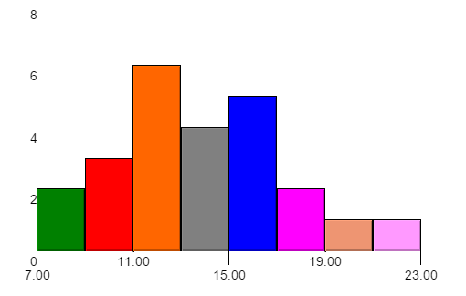 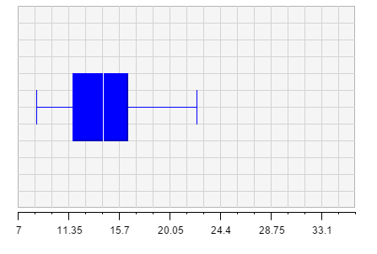

For the time needed to name the congruent words, most samples are located between 9s and 19s.

The highest frequency is between 11s and 13s.

4.2 Incongruent

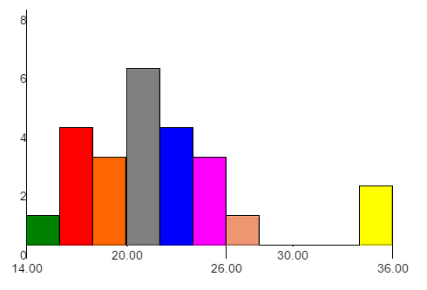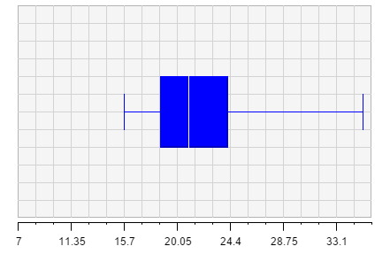

Although, some samples take extremely long time to name the color of incongruent words,

Most samples are centralized around 21s.

5. Now, perform the statistical test and report your results. What is your confidence level and your critical statistic value? Do you reject the null hypothesis or fail to reject it? Come to a conclusion in terms of the experiment task. Did the results match up with your expectations?

confidence level: 5%

critical statistic value: -2.069 and 2.069

|  |  |  |
| --- | --- | --- |
|  | Congruent | Incongruent |
| mean | 14.051125 | 22.01591667 |
| varience | |  | | --- | | 12.66902907 | | 23.01175704 |

s=4.865

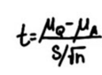

t=(14.051-2.016)/(4.865/(24)^0.5)= -8.02

Because t= -8.02 is smaller than the critical value -2.069, we must reject H0

In conclusion, the time it takes to name the ink colors for Congruent is significant different with that for Incongruent.

The results match up with my expectations

6. Optional: What do you think is responsible for the effects observed? Can you think of an alternative or similar task that would result in a similar effect? Some research about the problem will be helpful for thinking about these two questions!

For the Incongruent words, the color naming process may be disturbed by the word itself.

Or for the congruent words, the words help us to name the color much faster.

A similar task maybe, name the shape of different geometry with right or wrong name printed on it, record the time it takes.